DATE: 5/28/20

AUTHOR: Noah B

ESTIMATING EXCEL ADD-IN DOCUMENTATION

The Excel add-in currently accepts the following external inputs:

* CSV file with headers (output from Bluebeam PDF)

There is no limit to the amount of information that can be contained in the CSV file. However, for the reporting feature to work correctly, two columns (and their headers) must exist somewhere in the file. The two critical columns are:

“Space” (Contains the name of the associated equipment system)

“Subject” (Contains the specific phase code)

These column names come directly from Bluebeam’s defaults for the custom toolbox (discussed later in this document) used to produce the CSV file. Since this represents a strong dependency on Bluebeam and one of its particular configurations, design elements have been included to weaken this relationship.[1] It is very important that the import file matches the specified interface or else the reporting feature will not work correctly. It bears repeating that any import file is acceptable ***if and only if it contains headers and associated data for the two critical columns “Subject” and “Space”.*** As long as this condition is met, the import file can contain any amount of additional information and the order in which the critical columns appear is irrelevant.

Shown below are two examples of acceptable, workable import files. The first contains nothing *but* the critical columns and is in fact the least likely to appear, due to the wide variety of Bluebeam versions and user configurations among company devices. The second is more typical of how field report files will look in practice. Since both files contain headers and associated data for the critical columns, both files are acceptable.



Figure 1 - Minimum Required Headers

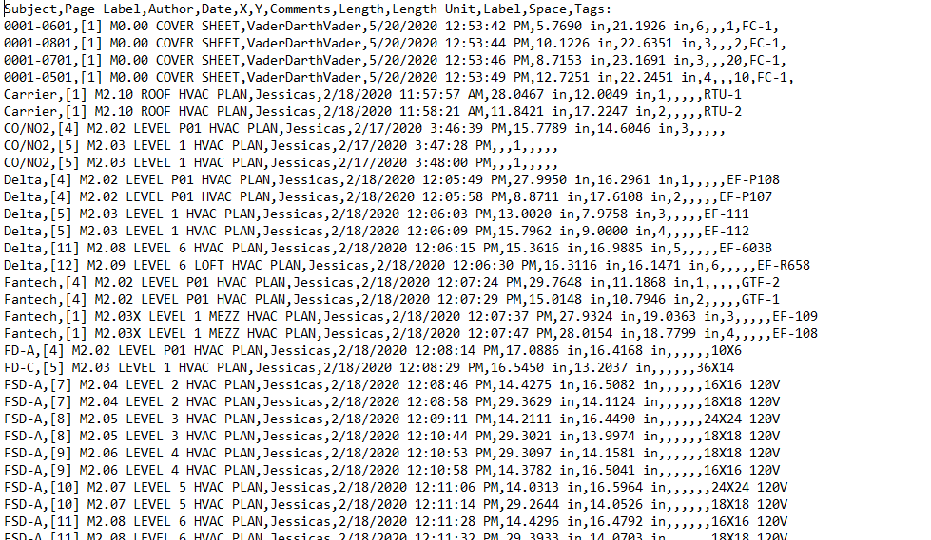

Figure 2 - Typical Example

In Figure 2, notice the presence and absence of information, as well as the apparent lack of homogeneity for data values within any single column. One of the features of the add-in is that the reporting feature remains unphased by this mishmash; it is quite capable of filtering out what it needs and ignoring the rest. What’s important here is that the sufficient condition *has been met*, not that it has been exceeded.

General Comments on the CSV format

In figures 1 & 2, make note of the following:

1. The headers, which represent the column names, appear in the first line of the file.
2. No Spaces appear between the first letter of a header entry and the comma before it. For example: “Subject,Space” is allowed, but “Subject, Space” is not allowed.

As long as these rules are followed, you can create an importable CSV field report for the Excel add-in using any application you wish, not just Bluebeam.

Formatting Requirements

All this flexibility is provided by establishing some very rigid conditions. Only the disciplined are free. The following list outlines non-negotiable format requirements that must be met for the application to work.

1. Job Numbers must contain exactly 7 numeric digits. Non numeric characters are not allowed. (EXAMPLE: Job #217-0507 must be entered as “2170507”)[2].
2. The CSV file must contain headers and associated data for the critical fields, as described in this section. Since the requirements were reiterated several times, they won’t be repeated here.
3. Phase Codes must obey the format ‘0000-0000’ (a group of 4 numeric characters followed by another group of 4 numeric characters, with a hyphen between the two groups). This is not currently the format used by SPECTRUM, so it is an expedient choice. There are two critical areas that must be checked for phase code formats: 1) the Estimating sheet containing the job estimate, and 2) the Bluebeam toolbox used to mark the phase codes. The formatting in these two sources must be the same; if it is, then the CSV file is almost guaranteed to have the correct formatting, and the file can be processed correctly.

1. For example, a helper class was added to the CSV file reader utility to assign the values of “Space” and “Subject” to their corresponding properties within the ‘PhaseCode’ object (reference Estimating.ProgressReporter.Model for the PhaseCode class definition; reference Estimating.CSVHandler for the PhaseCodeHelper class definition). This decouples the PhaseCode object’s property names from the specific file header names in case they should ever change. In addition, the disclosed CSV import template example serves as an explicit interface for any (non-Bluebeam) application wishing to produce a workable import file. Both of these features add flexibility. Hence, the formerly tight dependency on Bluebeam has been made much looser.
2. This is not an arbitrary choice. SPECTRUM stores job numbers in a fixed-width field of 10 characters, padding the beginning with spaces to round this out. For example, job number ‘2170507’ is stored in SPECTRUM as ‘ 2170507’ (padded with 3 spaces at the beginning). Previous EAI practice was to assign letter suffixes and other formats as needed, and applications like SILO and AIRE are aware of the 10-character field width and are prepared to handle this case. However, current (and future?) policy is to restrict job numbers to 7 numeric characters as described.